**FORMAN CHRISTIAN COLLEGE**

**(A CHARTERED UNIVERSITY)**



**CSCS 306 - A**

**FALL 24**

**4-Digit Stopwatch using Arduino**

**Assignment 1 Report**

Hafsah Shahbaz – 251684784

Daim Bin Khalid - 251686775

Syeda Manal Ammad - 251606966

14th October 6, 2024

**Table of Contents**

1. Introduction

2. Components Used

3. Circuit Diagram

4. Image of the Working Hardware

5. Code Breakdown

6. References

**Introduction**

This project involves the design and implementation of a 4-digit stopwatch using Arduino. The stopwatch counts minutes and seconds on a four-digit, multiplexed 7-segment display. Users can input minutes and seconds using a keypad, which are then displayed on the stopwatch. Once started, the stopwatch counts down and resets to zero when the time runs out. When the countdown reaches zero, the display shows **FCCU** and blinks it four times before resetting. The stopwatch can also be started to count-up if started at 0. The counter can be paused and reset as well.

This project highlights skills such as interfacing Arduino with external hardware components like 7-segment displays, push buttons, and keypads. The challenge of the project is to utilize limited Arduino pins ideally while using a shift register to counter this problem. The code logic also emphasizes real-time counting using millis(), ensuring accurate timekeeping.

**Components Used**

1. Arduino Uno R3

2. 1x 7-Segment Anode Display (4 Digits)

3. 1x Shift Register (74HC595)

4. Keypad (4x4)

5. 4x 330 Ohm Resistors

6. Jumper Wires and Breadboard

**Circuit Diagram (TinkerCAD)**

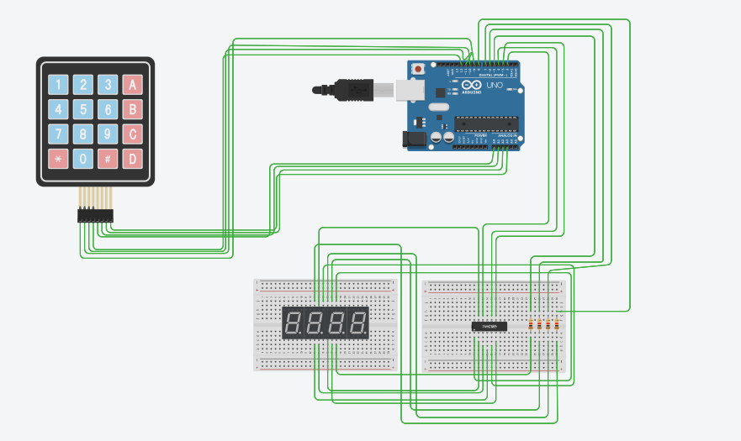

**Image of the Working Hardware**

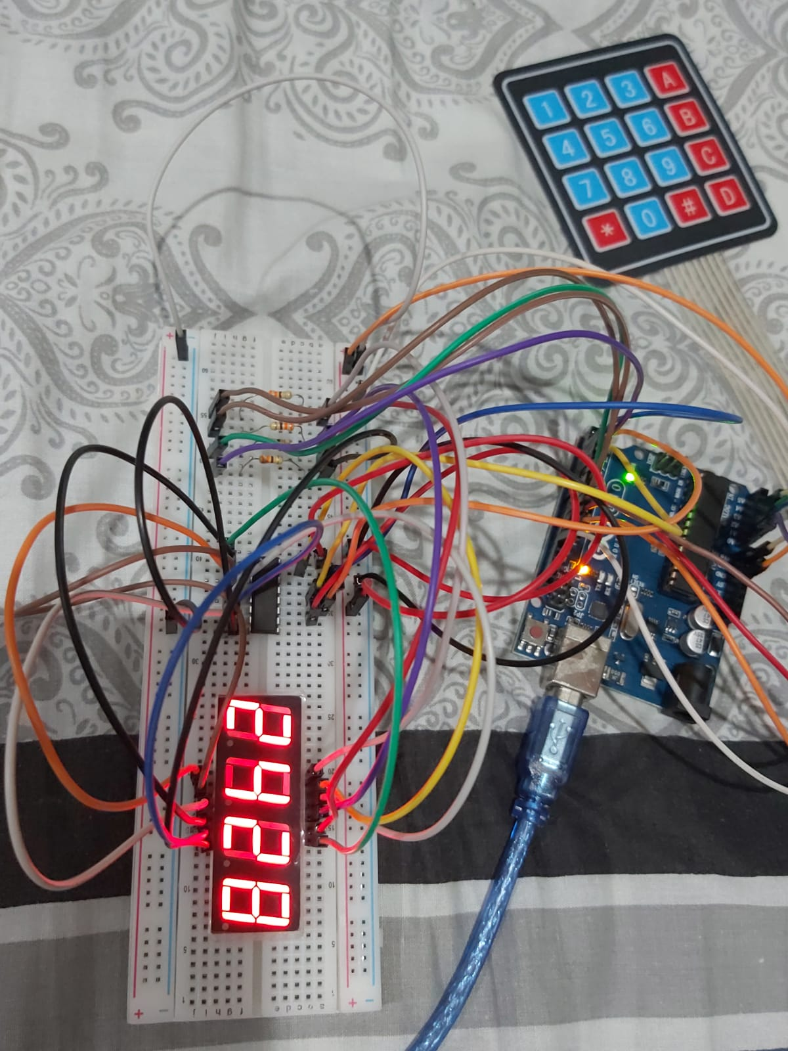

**Functionality and Code Breakdown**

**1. Stopwatch Setup and Pin Configuration**

**Summary:** The setup initializes pins and configures the 4-digit 7-segment display for use with a shift register.

const int dataPin = 2; // DS (Data Pin)

const int latchPin = 4; // ST_CP (Latch Pin)

const int clockPin = 3; // SH_CP (Clock Pin)

**dataPin, latchPin, clockPin:** Define the pins used for controlling the 74HC595 shift register that drives the 7-segment display.

pinMode(DIGIT_1_PIN, OUTPUT);

pinMode(DIGIT_2_PIN, OUTPUT);

pinMode(DIGIT_3_PIN, OUTPUT);

pinMode(DIGIT_4_PIN, OUTPUT);

**DIGIT_X_PIN**: Defines the pins connected to each of the 4 digits of the 7-segment display.

**2. Handling Keypad Inputs**

**Summary:** The code captures keypad inputs to set minutes/seconds, start/stop the stopwatch, and reset the timer.

switch (key) {

case 'A': // Edit seconds

case 'B': // Edit minutes

case 'C': // Start/Stop stopwatch

case 'D': // Reset stopwatch

**Keypad Input Handling:** Detects which key has been pressed ('A' to edit seconds, 'B' to edit minutes, 'C' to start/stop the stopwatch, and 'D' to reset).

**3. Time Modification Logic**

**Summary:** When the user presses a number key after selecting "Edit Minutes" or "Edit Seconds," the value is updated.

if (editingSeconds && key >= '0' && key <= '9') {

int value = key - '0'; // Convert char to int

seconds = (seconds * 10 + value) % 60; // Limit to 0-59

}

**Editing Seconds/Minutes:** Allows the user to set the time by converting the character input from the keypad into an integer and updating the time.

**4. Countdown and Count-up Timer Logic**

**Summary:** The stopwatch can operate in countdown mode (default) or count-up mode (if time is 00:00).

if (countingUp) {

seconds++;

if (seconds > 59) { seconds = 0; minutes++; }

} else {

seconds--;

if (seconds < 0) { seconds = 59; minutes--; }

}

**Count-Up Logic:** If countingUp is true, the seconds increment and the stopwatch behaves as a count-up timer.

**Countdown Logic:** If countingUp is false, the seconds decrement, and the stopwatch counts down.

**5. Displaying Time on the 7-Segment Display**

**Summary: Time (minutes and seconds) is continuously updated and displayed using multiplexing on the 4 digits of the display.**

void displayTime() {

digitalWrite(DIGIT_1_PIN, HIGH); // Show ones of seconds

showDigit(digitCode[seconds % 10]);

digitalWrite(DIGIT_1_PIN, LOW);

digitalWrite(DIGIT_2_PIN, HIGH); // Show tens of seconds

showDigit(digitCode[seconds / 10]);

digitalWrite(DIGIT_2_PIN, LOW);

digitalWrite(DIGIT_3_PIN, HIGH); // Show ones of minutes

showDigit(digitCode[minutes % 10]);

digitalWrite(DIGIT_3_PIN, LOW);

digitalWrite(DIGIT_4_PIN, HIGH); // Show tens of minutes

showDigit(digitCode[minutes / 10]);

digitalWrite(DIGIT_4_PIN, LOW);

}

**Multiplexing Digits:** Each digit is displayed one by one using multiplexing, where only one digit is active at a time.

**showDigit():** Sends the appropriate digit pattern to the shift register based on the current time.

**6. Displaying "FCCU"**

**Summary:** When the countdown reaches 00:00, the display blinks "FCCU" four times.

void displayFCCU() {

for (int blinkCount = 0; blinkCount < 4; blinkCount++) { // Blink 4 times

// Display "FCCU" for 500ms

for (int i = 0; i < 15; i++) { // Refresh display for 500ms (5ms * 100 = 500ms)

// Display F

showDigit(FCCU[0]);

digitalWrite(DIGIT_4_PIN, HIGH);

delay(5);

digitalWrite(DIGIT_4_PIN, LOW);

// Display C (first C)

showDigit(FCCU[1]);

digitalWrite(DIGIT_3_PIN, HIGH);

delay(5);

digitalWrite(DIGIT_3_PIN, LOW);

// Display C (second C)

showDigit(FCCU[1]);

digitalWrite(DIGIT_2_PIN, HIGH);

delay(5);

digitalWrite(DIGIT_2_PIN, LOW);

// Display U

showDigit(FCCU[2]);

digitalWrite(DIGIT_1_PIN, HIGH);

delay(5);

digitalWrite(DIGIT_1_PIN, LOW);

}

// Turn off the display (clear) for 500ms

clearDisplay();

delay(500);

}

}

**FCCU Blinking:** The letters 'F', 'C', 'C', and 'U' are displayed using the predefined segment codes in the chars[] array. The display blinks 4 times before the stopwatch is reset.

**7. Reset Functionality**

**Summary:** Resets the stopwatch to 00:00 and stops it from running or counting up.

void resetStopwatch() {

minutes = 0;

seconds = 0;

running = false;

countingUp = false;

displayTime();

}

**Reset Stopwatch:** Resets the minutes, seconds, running, and countingUp variables, stopping the timer and displaying "00:00".

**8. Clear Display**

**Summary:** Turns off all segments of the display for a short period to achieve the blink effect.

void clearDisplay() {

shiftOut(dataPin, clockPin, MSBFIRST, 0xFF); // Clear digit (turn off segments)

}

**9. showDigit() Function**

**Summary:** Sends the appropriate binary pattern to the shift register to display a specific digit.

void showDigit(byte digitValue) {

digitalWrite(latchPin, LOW);

shiftOut(dataPin, clockPin, MSBFIRST, digitValue); // Send digit pattern

digitalWrite(latchPin, HIGH);

}

**showDigit():** Uses shiftOut to transmit the digit pattern (e.g., for numbers 0-9 or letters like 'F', 'C', 'U') to the display.

**References**

1. 74HC595N Shift Register Datasheet: <https://datasheet.octopart.com/74HC595N-Philips-datasheet-7085704.pdf>

2. Keypad Library Documentation: [Keypad | Arduino Documentation](https://docs.arduino.cc/libraries/keypad/)

3. 4 Digit 7-Segment Display Tutorial: <https://youtu.be/3m4jhmafg8E?si=kEl6X-NRuPXs0exU>